Just in Time
Presentville's laboratory created a tear in space-time, trapping the city in a destructive vortex somewhere outside of reality. The players must work together, traveling through time and place, to realign their recent history before it, and they, cease to exist.

Just in Time is a real-time cooperative abstract on time-travel for 1 to 4 players. Players take actions as quickly or slowly as they wish, taking their turns independently of one another. The players all win or lose as a team depending on whether they are able to successfully stabilize space-time.

Components
1x Game Board with Time Dials 108x Player Cards – 6 decks of 18 cards
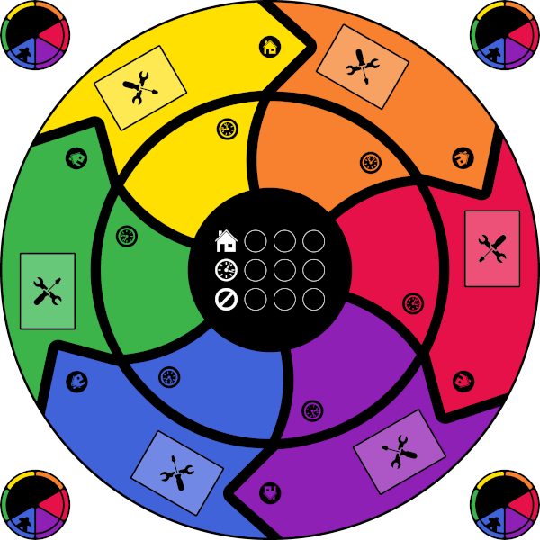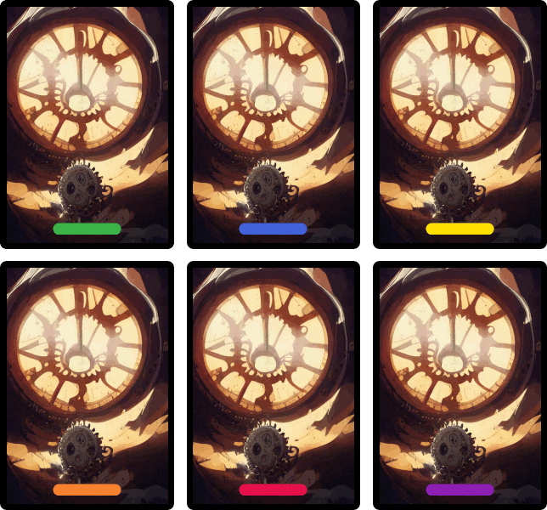

12x Construction Tokens 12x Player Meeples
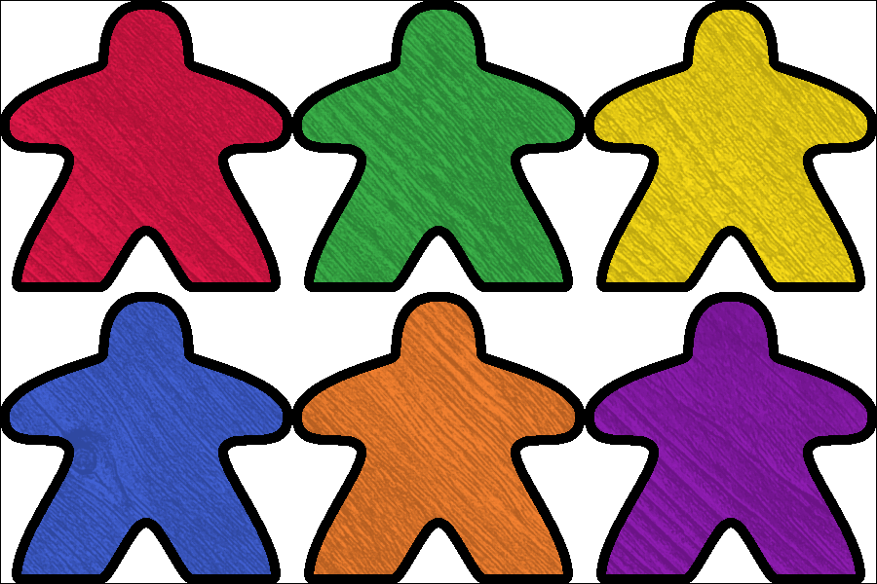
48x Space-Time Shard Tokens – 8 each of 6 colors and double-sided
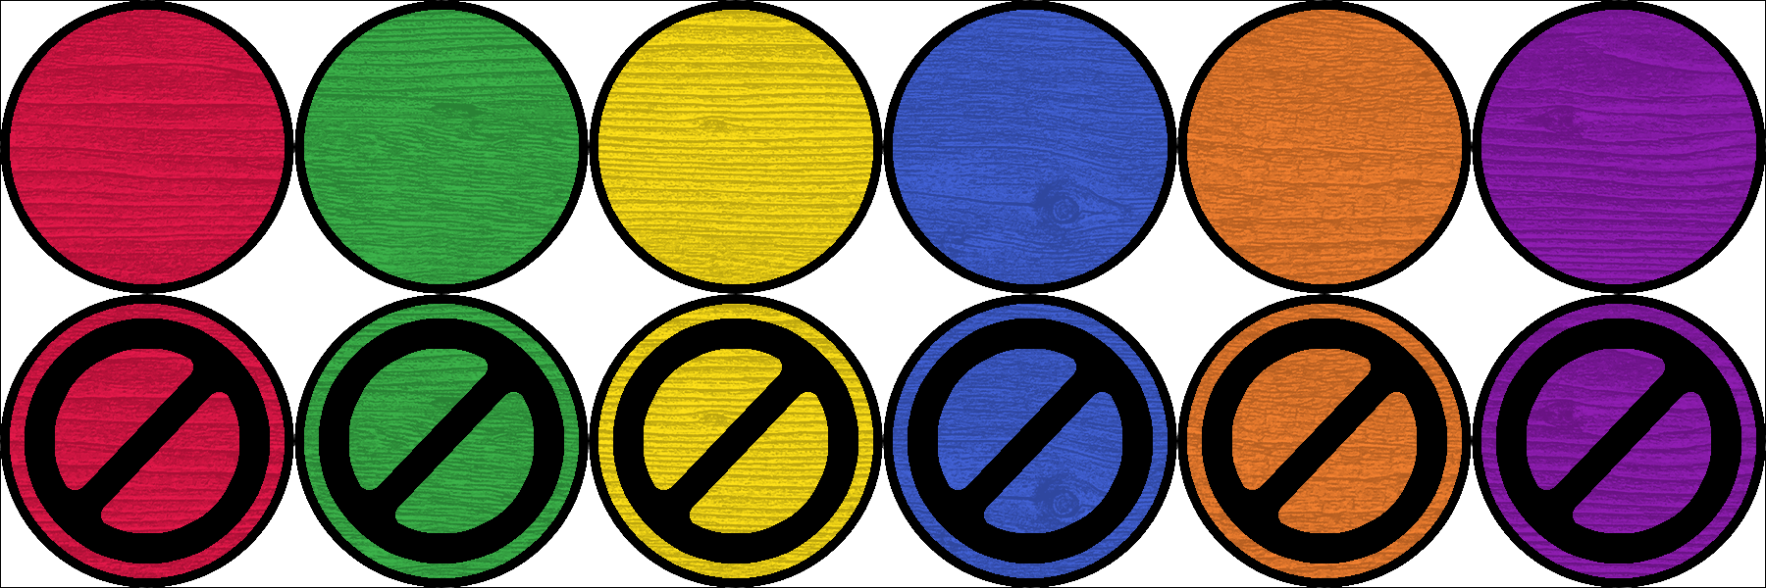
Overview
Throughout the game each player controls 2 meeples: 1 on the place spaces representing where they exist and 1 on the time spaces representing when they exist.

The game is played over 1 or 2 rounds. For each round there are specific places and times that must be aligned to proceed. Players activate actions on their cards and constructs to move about the board and alter space-time shards until the required alignments are complete.

Players must successfully complete each round in order to win.
The players lose if all player cards are spent without completing the round.

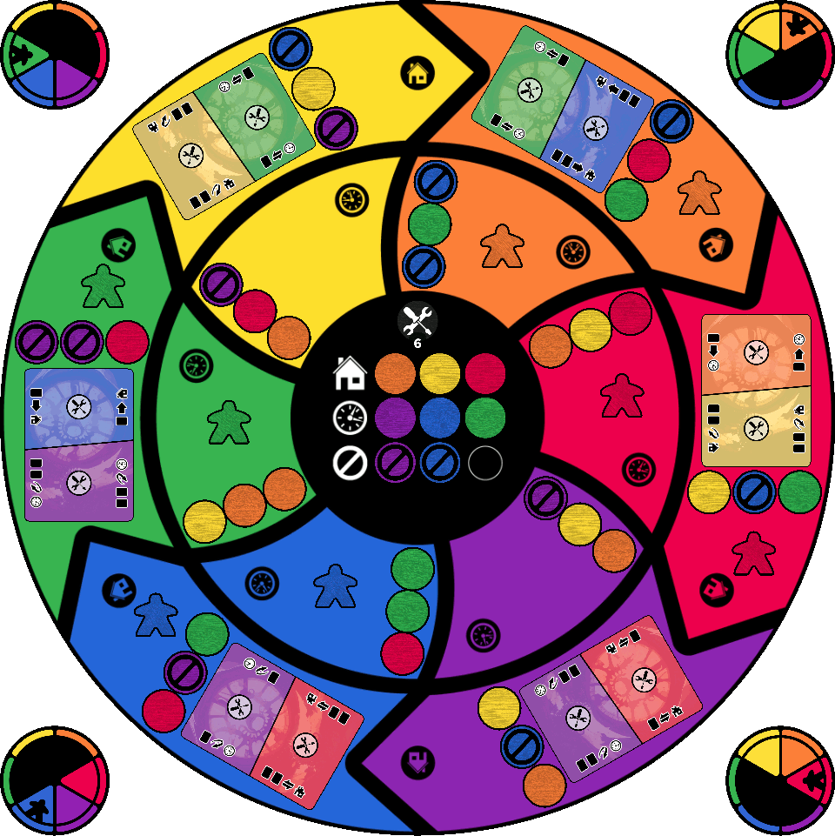
Game Play
Time has looped back on itself, meaning that a player's distant future is also their past. The time space a player’s meeple sits on is their present time. The 2 time spaces counter-clockwise from that time are in their past and the remaining 3 time spaces are in their future.

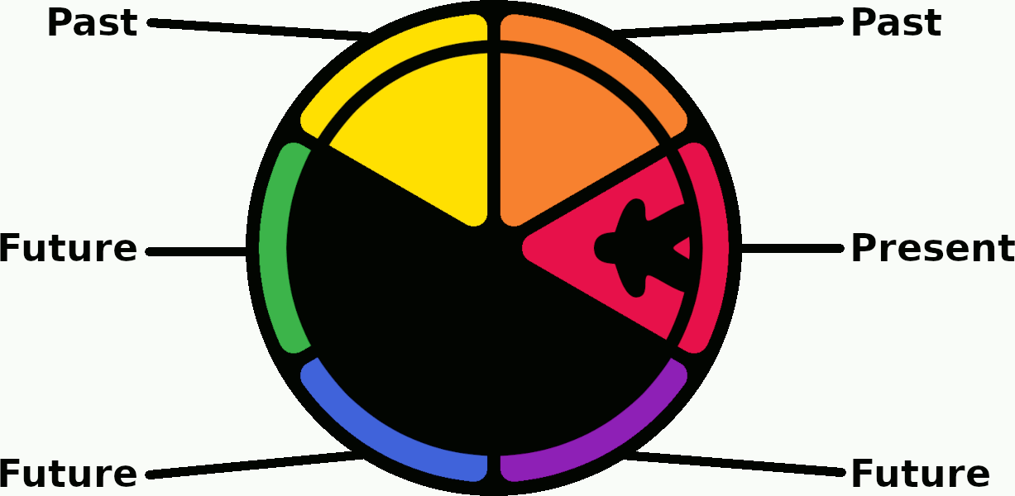

Most actions require a card or shard to exist for the player in order to be affected:
Cards » must be physically located on a place space in the player’s past or present
Shards » must match color with 1 of the player’s past or present time-spaces

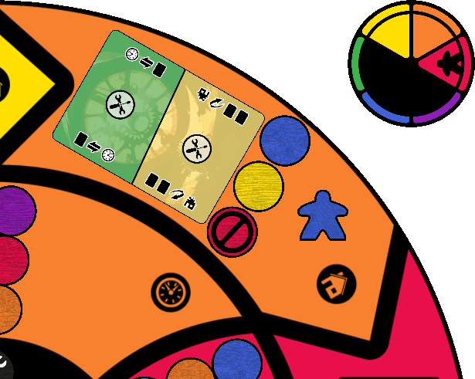

At the start of each round 3 goal tokens will be revealed that represent part of the timeline that has become unstable. Another 3 goal tokens will be revealed for places, representing the same.

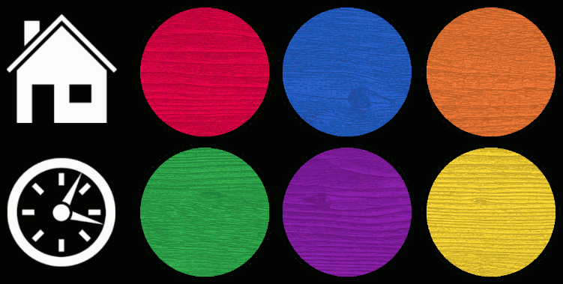

Game Play – Continued
Shards on the board will be flipped throughout the game to their marked side. Marked shards do not count toward completing the current round. They can however be repaired to their blank side through player actions.

In order to complete the round, players must change the shards on the time spaces matching the goal tokens to contain the place goal token colors and change the tokens on the place spaces to match the time goal token colors.

Example
The goal area contains orange, red and purple tokens in the place slots as well as blue, green and yellow tokens in the time slots. To complete the round the game board must contain blue, green and yellow shards on the orange, red and purple place spaces as well as orange, red and purple shards on the blue, green and yellow time spaces. Each of these shards must be blank-side up.

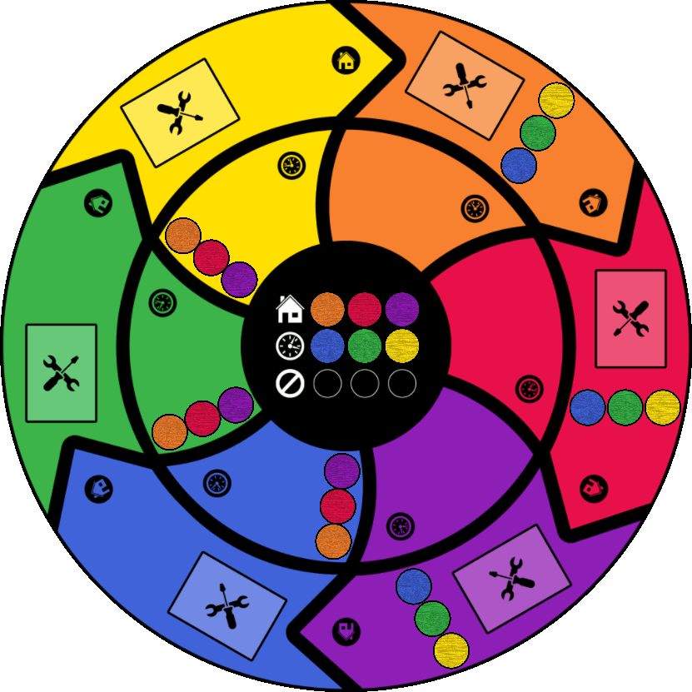
Actions
Cards are either played to activate their primary or secondary action, or discarded to pay the cost of another card’s action. Any time a player has less than 5 cards in their hand they draw cards from their deck until back to 5 cards or as many as possible should their deck run out.

Card Actions
To activate an action on a card in a player’s hand they first place the card on the table in front of themselves and then discard either 1 card to activate the card’s primary action or they discard 2 cards to active the card’s secondary action.

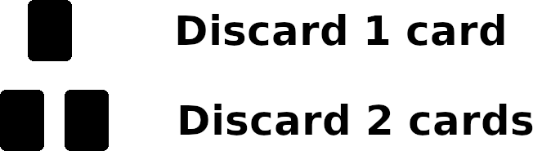

After discarding the player then resolves the action and discards the card itself:

Move
 Move your place-meeple to an adjacent place space
 Move your time-meeple to an adjacent time space

Flip
 Flip a shard on your place-meeple’s space to blank-side up
 Flip a shard on your time-meeple’s space to blank-side up

The shard must exist, i.e., match color with one of the player’s past or present time spaces.

Actions – Continued
Swap

Swap a shard from the player’s place-meeple space with a token from their time-meeple space.

Swap a shard from the player’s time-meeple space with a token from their place-meeple space.

The originating shard (underlined) must exist, i.e., match color with one of the player’s past or present time spaces, in order to be swapped. The destination shard may be any color.

Example
Both of the green shards are valid and could be swapped with the blue or purple shards.
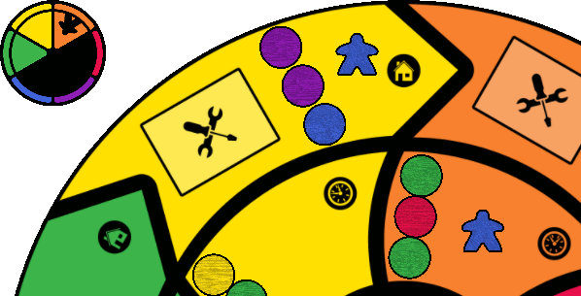

Example
Only the red shard is valid and could be swapped with the green, yellow or orange shards.
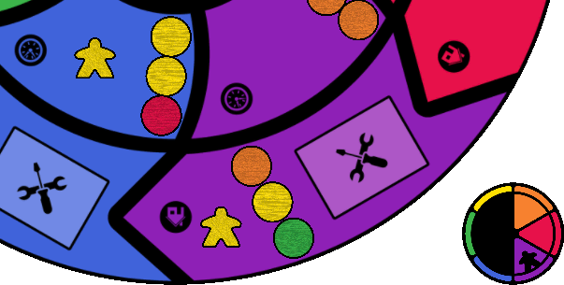
Construction
During setup 6 cards will be placed face-up on the game board which represent various locations now inaccessible due to the disruptions to space-time. As players repair space-time these locations will also repair and provide the players with additional action options.
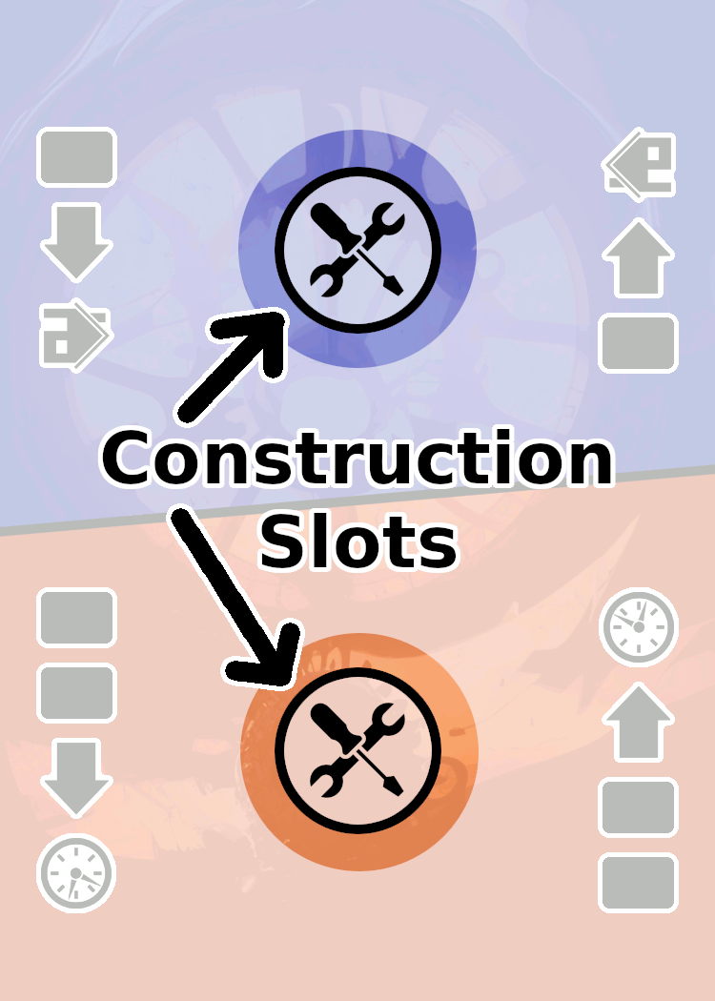

Each card has 2 construction slots, 1 for its primary action and 1 for its secondary action, which can be filled with a construction token to unlock access to that action for the remainder of the game

Each time a player completes the goal for an individual space on the board:
- Remove the 3 shards from the game
- Take 1 construction token from the center of the board
- Place the construction token on any available construction slot

Example
Here the blue player has completed the goal for the red place space and chosen to place a construction token on the primary action slot of the construction card on the red place space.

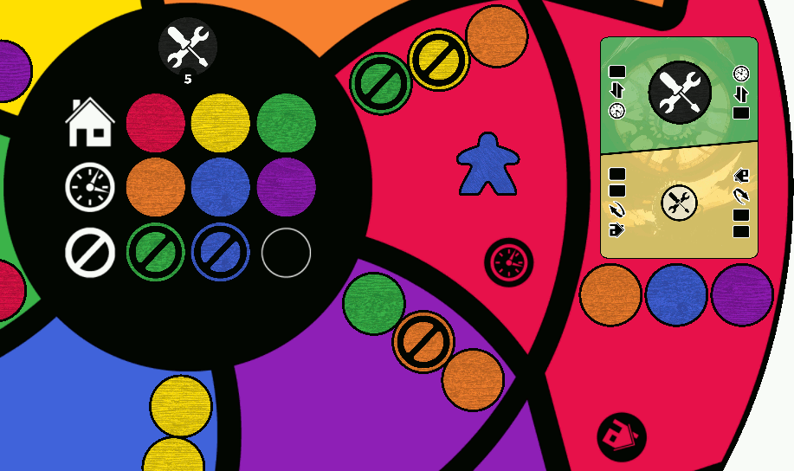
Construction – Continued
To activate an action a player’s place-meeple must be on the card’s place space and the card must exist, i.e., be in the player’s past or present. The player discards the required cards, 1 for primary or 2 for secondary, and then resolves the action.

Example
Here the blue player is on the red place space along with the construction they just completed. Red is in their past so the card exists for them and can be activated by discarding the 1 card required for the primary action.

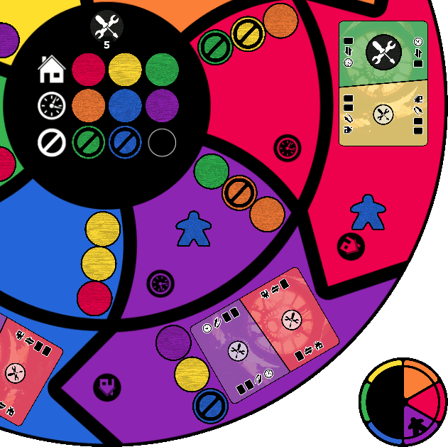
Setup
Place the game board in the center of the table within easy reach of all players.

Separate 1 of each color space-time shard for use as goal tokens. Mix the goal tokens and place them on the 6 goal spaces: 3 for places and 3 for times.

Separate 1 of each color space-time shard for use as damage tokens. Mix the damage tokens and place 2 or 3 of them on the damage spaces setting the rest aside:
Normal » 2 tokens
Expert » 3 tokens

Mix the remaining shards and randomly place 3 on each place and time space blank-side up. Flip every shard matching any of the damage token colors to their marked side.

Place 6 or 12 of the construction tokens in the empty space in the center of the board:
Quick » 6 tokens
Complete » 12 tokens

Each player chooses a color, taking the 2 matching meeples, and then places 1 of the meeples each on their matching colored place and time spaces. Players rotate their time dials to so that their current time space color is marked as their present time.

Individually shuffle 4 of the player decks and divide them among the players:
4 players » Each player takes 1 deck
3 players » Evenly divide 1 deck among the players then each player stacks 1 deck on top
2 players » Each player stacks 2 decks together
1 player » The player stacks all 4 decks together

Shuffle an unused player deck and deal 1 card face-up to each of the 6 construction spaces on the game board.

Return all other unused cards and meeples to the box.

Players place their decks face-down in front of them and draw a hand of 5 cards.

Setup – Continued
In this example 4 players have setup a quick game (6 construction tokens) on normal difficulty
(2 damage tokens) and are ready to begin.

End Game & Extended Play
The players are free to take actions until either the goal has been completed or the players have ran out of cards. Players do not take turns; they each activate and resolve their actions as quickly or slowly as they wish independently of one another.

If the players run out of cards before completing the goal then the players lose the game forever lost as Presentville’s space-time ceases to exist.

Successfully completing the goal ends the game in victory for the players saving Presentville as place and time restore to their rightful ways.

Complete Game
For the full game experience follow the below setup once the first goal has been completed:
- Swap the 3 place goal tokens with the 3 time goal tokens
- Return the damage tokens to the box and replace with those unused from the first round
- Flip the space-time shards matching color with the new damage tokens to their marked side

In this example the goal tokens have been swapped, the green / blue damage tokens have been replaced with orange / yellow and the orange / yellow shards have been flipped.

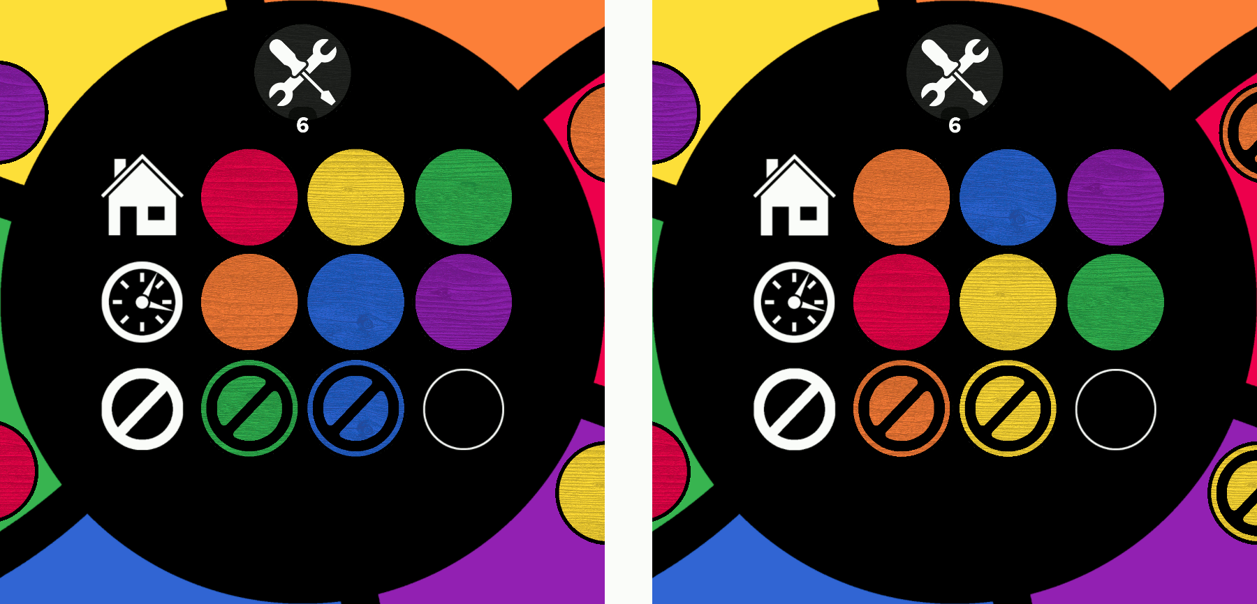

Players then resume taking actions attempting to complete a second round.

Once per game each player may discard all remaining cards from their deck and hand, and then flip their discard pile, without shuffling, into a new deck.

The players win if they can complete the 2nd goal prior to running out of cards.

Example Game Play
Here the red player notices a quick solution for the red place space. They begin the game with the effect to flip the orange shard, which exists in their past, on their place space discarding 1 other card to pay its cost.

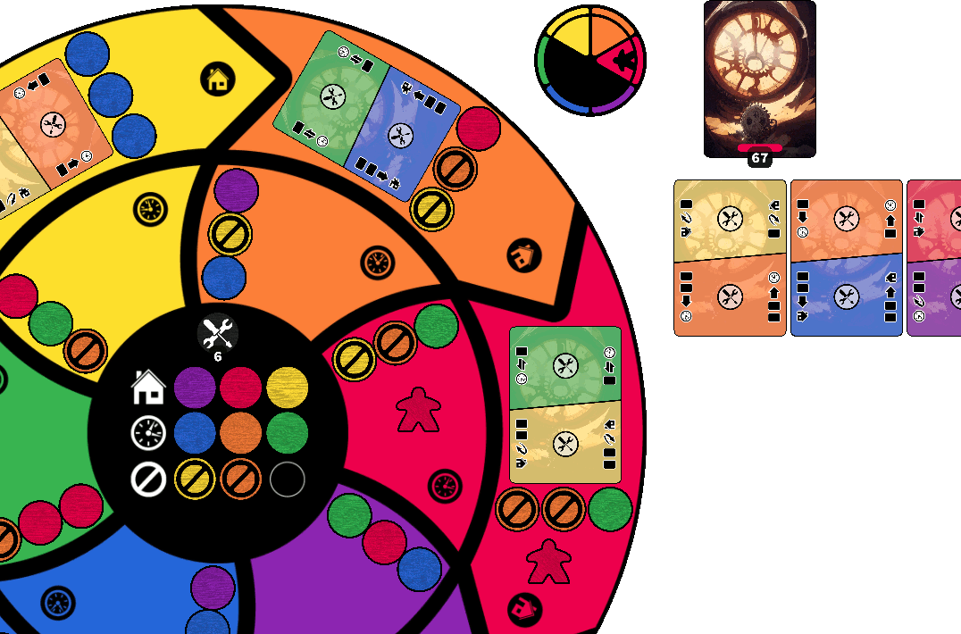

They then resolve the effect to move their time-meeple to move into the orange time space again discarding 1 card to pay the effect’s cost. They also rotate their time dial to match.

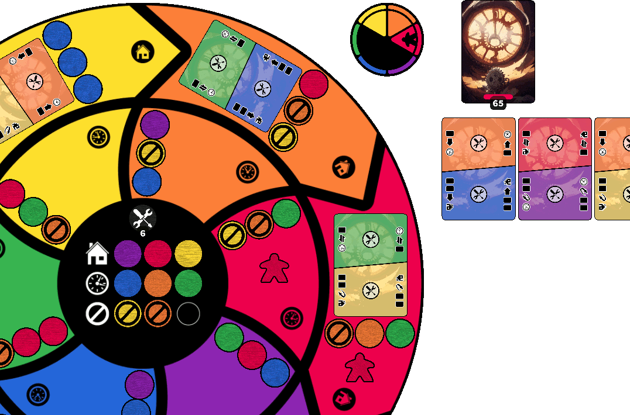
Example Game Play – Continued
The red player then uses the effect to swap a place space shard with their time space. They discard 1 card to pay the cost and select the marked orange shard, which exists in their present, to swap with the blank blue shard (even though the blue shard is in their future).

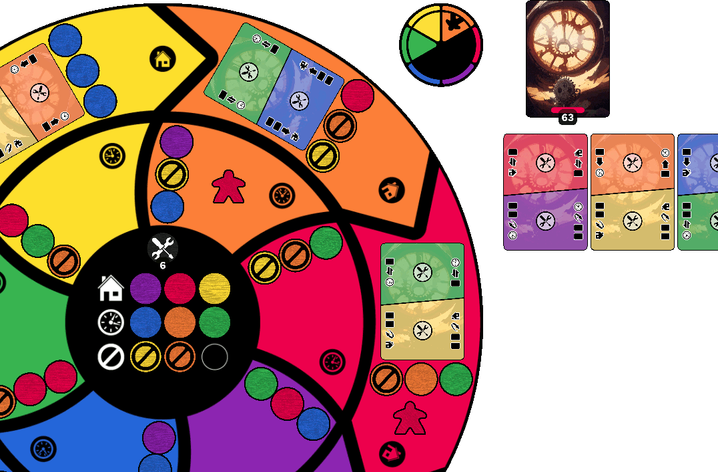

This completes the goal for the red place space and earns the player a construction token. They place the token on the primary effect slot of the red place space card and continue play.

